Name___________________ Class______________ Date________
Biology H Anaerobic Respiration
Write true if the statement is true or false if the statement is false.
_____ 1. Fermentation is the process of making ATP in the presence of oxygen.
_____ 2. Aerobic respiration evolved after oxygen was added to Earth’s atmosphere.
_____ 3. Anaerobic respiration lets organisms live in places where there is little or no oxygen.
_____ 4. Alcoholic fermentation explains why bread dough rises.
_____ 5. Fermentation recycles NADP⁺.
_____ 6. Anaerobic respiration is a very slow process.
_____ 7. Some plants and fungi and many bacteria do not need oxygen.
_____ 8. Some organisms may not be able to survive in the presence of oxygen.
_____ 9. Alcoholic fermentation explains why your muscles are sore after intense exercise.
_____ 10. There are three types of fermentation: anaerobic, aerobic, and cellular.
_____ 11. Some organisms can use both aerobic and anaerobic respiration.
_____ 12. Most living things use glucose to make ATP from oxygen.
_____ 13. Bread rises because of alcoholic fermentation.
_____ 14. Fermentation allows glycolysis to continue in the absence of oxygen.
_____ 15. Anaerobic respiration produces much more ATP than aerobic respiration.
Read these passages from the text and answer the questions that follow.
Fermentation
An important way of making ATP without oxygen is called fermentation. It involves glycolysis but not the other two stages of aerobic respiration. Many bacteria and yeasts carry out fermentation. People use these organisms to make yogurt, bread, wine, and biofuels. Human muscle cells also use fermentation. This occurs when muscle cells cannot get oxygen fast enough to meet their energy needs through aerobic respiration.
There are two types of fermentation: lactic acid fermentation and alcoholic fermentation. Both types of are described below.
Lactic Acid Fermentation
In lactic acid fermentation, pyruvic acid from glycolysis changes to lactic acid. In the process, NAD⁺ forms from NADH. NAD⁺, in turn, lets glycolysis continue. This results in additional molecules of ATP. This type of fermentation is carried out by the bacteria in yogurt. It is also used by your own muscle cells when you work them hard and fast.
Did you ever run a race and notice that your muscles feel tired and sore afterward? This is because your muscle cells used lactic acid fermentation for energy. This causes lactic acid to build up in the muscles. It is the buildup of lactic acid that makes the muscles feel tired and sore.
Alcoholic Fermentation
In alcoholic fermentation, pyruvic acid changes to alcohol and carbon dioxide. NAD⁺ also forms from NADH, allowing glycolysis to continue making ATP. This type of fermentation is carried out by yeasts and some bacteria. It is used to make bread, wine, and biofuels.
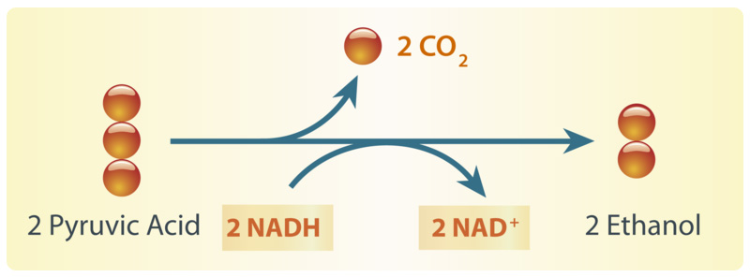
Alcoholic fermentation produces ethanol and NAD⁺. The NAD⁺ allows glycolysis to continue making ATP.
Have your parents ever put corn in the gas tank of their car? They did if they used gas containing ethanol. Ethanol is produced by alcoholic fermentation of the glucose in corn or other plants. This type of fermentation also explains why bread dough rises. Yeasts in bread dough use alcoholic fermentation and produce carbon dioxide gas. The gas forms bubbles in the dough, which cause the dough to expand. The bubbles also leave small holes in the bread after it bakes, making the bread light and fluffy.
Questions
1. What is fermentation?

2. Why is NAD⁺ so important in fermentation?

3. Both lactic acid fermentation and alcoholic fermentation begin with the same molecule. What is that molecule and where did it come from?

4. Why is bread light and fluffy?

5. Why do your muscles get sore after intense activity?

Circle the letter of the correct choice.
- Complete this sentence: Most living things use ____________ to make ____________ from glucose.
  - oxygen, ATP b. ATP, oxygen c. NADH, NAD⁺ d. oxygen, NAD⁺
- Which of the following organisms can perform alcoholic fermentation? (1) yeast, (2) humans, (3) bacteria.
  - 1 only b. 1 and 2 c. 1 and 3 d. 1, 2, and 3
- Which of the following is true about anaerobic respiration?
  - It is a very fast process.
  - It allows organisms to live in places where there is little or no oxygen.
  - It evolved before aerobic respiration.
  - All of the above are true.
- In alcoholic fermentation
  - carbon dioxide is released. c. NADH is recycled.
  - lactic acid is produced. d. all of the above
- Fermentation involves which stages of cellular respiration? (1) glycolysis, (2) the Krebs cycle, (3) electron transport.
  - 1 only b. 1 and 2 c. 2 and 3 d. all three stages

- In lactic acid fermentation
  - carbon dioxide is released. c. NADH is recycled.
  - lactic acid is produced. d. all of the above
- After intense activity, your muscles feel sore because of
  - the accumulation of NAD⁺. c. the accumulation of lactic acid.
  - the accumulation of ATP. d. the accumulation of carbon dioxide.
- Both alcoholic fermentation and lactic acid fermentation
  - start with pyruvic acid. c. recycle NAD⁺ from NADH.
  - allow glycolysis to continue. D. all of the above

Match the vocabulary word with the proper definition.
Definitions
_____ 1. an important way of making ATP without oxygen
_____ 2. respiration in the absence of oxygen
_____ 3. makes your muscles feel tired and sore after intense exercise
_____ 4. recycles during fermentation
_____ 5. perform cellular respiration in the presence of oxygen
_____ 6. can use lactic acid fermentation for energy
_____ 7. can use alcoholic fermentation for energy
_____ 8. stage of cellular respiration that occurs with or without oxygen
_____ 9. product of glycolysis
_____ 10. energy in the cell
_____ 11. fermentation in which pyruvic acid from glycolysis changes to lactic acid
_____ 12. fermentation in which pyruvic acid changes to alcohol and carbon dioxide
Terms
a. aerobic organisms
b. alcoholic fermentation
c. anaerobic respiration
d. ATP
e. fermentation
f. glycolysis
g. lactic acid
h. lactic acid fermentation
i. muscle cells
j. NAD⁺
k. pyruvic acid
l. yeast

Fill in the blank with the appropriate term.
1. A way of making ____________ without oxygen is called fermentation.
2. During lactic acid fermentation, NAD⁺ cycles back to allow ____________ to continue.
3. Fermentation involves ____________, but not the other two stages of cellular respiration.
4. Aerobic respiration evolved after ____________ was added to Earth’s atmosphere.
5. In ____________ fermentation, pyruvic acid changes to alcohol and carbon dioxide.
6. Organisms that can make ATP without oxygen include some plants and ____________ and also of many bacteria.
7. In ____________ fermentation, pyruvic acid from glycolysis changes to lactic acid.
8. The small holes in bread are formed by bubbles of ____________ gas, which is produced by alcoholic fermentation in yeast.
9. Without oxygen, organisms can just split glucose into ____________ molecules of pyruvate.
10. ____________ in bread dough use alcoholic fermentation and produce carbon dioxide gas.
11. Aerobic respiration produces much more ____________ than anaerobic respiration.
12. Most organisms use oxygen to make ____________ from glucose.
Thoroughly answer the question below. Use appropriate academic vocabulary and clear and complete sentences.
Compare aerobic and anaerobic respiration, and discuss the advantages of each.

