AP Biology QW14 1-14
1-
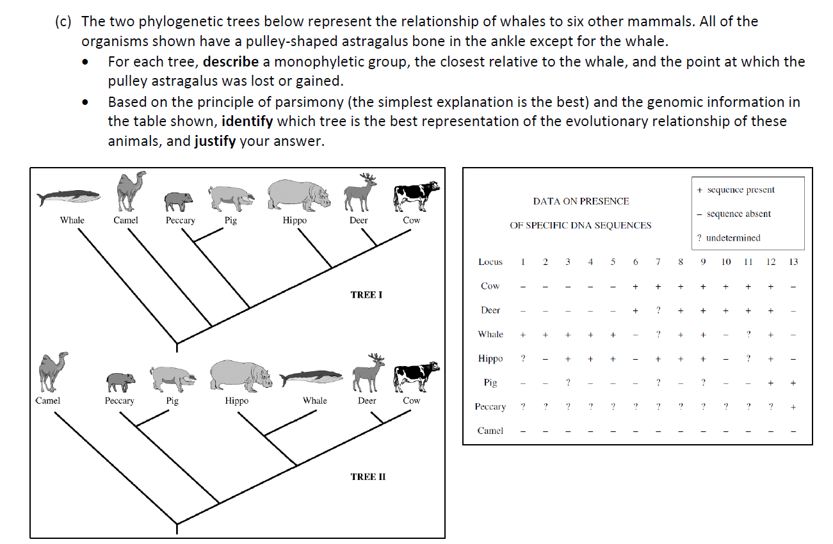
2- You have sampled a population in which you know that the percentage of the homozygous recessive genotype (aa) is 36%. Using that 36%, calculate the following:
a. The frequency of the “a” allele: _________
b. The frequency of the “A” allele: _________
c. The frequency of the “aa” genotype: _________
d. The frequency of the “AA” genotype: _________
e. The frequency of the “Aa” genotype: _________

3- In humans, tongue rolling is dominant to non-rolling. In a population of 1000 individuals, 910 can roll their tongues. Calculate the following:
a. The frequency of the dominant allele: _________
b. The frequency of the recessive allele: _________
c. The percentage of the population that is homozygous dominant: _________
d. The percentage of the population that is heterozygous: _________
e. The percentage of the population that is homozygous recessive: _________

4- If 102 out of 200 individuals in a population express the dominant phenotype, what percent of the population are heterozygous?
5- 1 in 1700 US Caucasian newborns have cystic fibrosis. C is the normal allele, dominant over the recessive c. Individuals must be homozygous for the recessive allele to have the disease.
Assuming a Hardy-Weinberg Equilibrium, how many newborns would have cystic fibrosis in a population of 10,000 people?

