Cell Reproduction Unit Review

Multiple Choice
Identify the choice that best completes the statement or answers the question.

____ 1. What is a chromatid?
a. | a chromosome in of the cell cycle
b. | a replicate chromosome
c. | a chromosome found outside the nucleus
d. | a special region that holds two centromeres together
e. | another name for the chromosomes found in genetics

____ 2. If there are 20 chromatids in a cell, how many centromeres are there?
a. | 10
b. | 20
c. | 30
d. | 40
e. | 80

____ 3. For a newly evolving protist, what would be the advantage of using eukaryote-like cell division rather than binary fission?
a. | Binary fission would not allow for the formation of new organisms.
b. | Cell division would allow for the orderly and efficient segregation of multiple linear chromosomes.
c. | Cell division would be faster than binary fission.
d. | Cell division allows for lower rates of error per chromosome replication.
e. | Binary fission would not allow the organism to have complex cells.

____ 4. Which term describes centrioles beginning to move apart in animal cells?
a. | telophase
b. | anaphase
c. | prometaphase
d. | metaphase
e. | prophase

____ 5. Which is the longest of the mitotic stages?
a. | telophase
b. | anaphase
c. | prometaphase
d. | metaphase
e. | prophase

____ 6. Which term describes centromeres uncoupling, sister chromatids separating, and the two new chromosomes moving to opposite poles of the cell?
a. | telophase
b. | anaphase
c. | prometaphase
d. | metaphase
e. | prophase

____ 7. If there are 20 chromatids in a cell at metaphase, how many chromosomes are there in each daughter cell following cytokinesis?
a. | 10
b. | 20
c. | 30
d. | 40
e. | 80

Use the data in Table 12.1 to answer the following questions.

The data were obtained from a study of the length of time spent in each phase of the cell cycle by cells of three eukaryotic organisms designated beta, delta, and gamma.

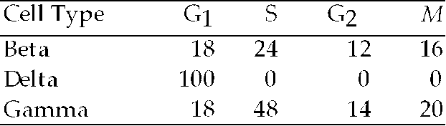

Table 12.1: Minutes Spent in Cell Cycle Phases

____ 8. Of the following, the best conclusion concerning the difference between the S phases for beta and gamma is that
a. | gamma contains more DNA than beta.
b. | beta and gamma contain the same amount of DNA.
c. | beta contains more RNA than gamma.
d. | gamma contains 48 times more DNA and RNA than beta.
e. | beta is a plant cell and gamma is an animal cell.

____ 9. Regarding mitosis and cytokinesis, one difference between higher plants and animals is that in plants
a. | the spindles contain microfibrils in addition to microtubules, whereas animal spindles do not contain microfibrils.
b. | sister chromatids are identical, but they differ from one another in animals.
c. | a cell plate begins to form at telophase, whereas in animals a cleavage furrow is initiated at that stage.
d. | chromosomes become attached to the spindle at prophase, whereas in animals chromosomes do not become attached until anaphase.
e. | spindle poles contain centrioles, whereas spindle poles in animals do not.

____ 10. Chromosomes first become visible during which phase of mitosis?
a. | prometaphase
b. | telophase
c. | prophase
d. | metaphase
e. | anaphase

____ 11. During which phases of mitosis are chromosomes composed of two chromatids?
a. | from interphase through anaphase
b. | from of interphase through metaphase
c. | from metaphase through telophase
d. | from anaphase through telophase
e. | from of interphase through metaphase

____ 12. A group of cells is assayed for DNA content immediately following mitosis and is found to have an average of 8 picograms of DNA per nucleus. Those cells would have ____ picograms at the end of the S phase and ____ picograms at the end of G₂.
a. | 8; 8
b. | 8; 16
c. | 16; 8
d. | 16; 16
e. | 12; 16

____ 13. Why do chromosomes coil during mitosis?
a. | to increase their potential energy
b. | to allow the chromosomes to move without becoming entangled and breaking
c. | to allow the chromosomes to fit within the nuclear envelope
d. | to allow the sister chromatids to remain attached
e. | to provide for the structure of the centromere

The following applies to the questions below.

Several organisms, primarily Protists, have what are called intermediate mitotic organization.

____ 14. Which of the following best describes how chromosomes move toward the poles of the spindle during mitosis?
a. | The chromosomes are "reeled in" by the contraction of spindle microtubules.
b. | Motor proteins of the kinetochores move the chromosomes along the spindle microtubules.
c. | Non-kinetochore spindle fibers serve to push chromosomes in the direction of the poles.
d. | both A and B
e. | A, B, and C

____ 15. Which of the following is a function of those spindle microtubules that do not attach to kinetochores?
a. | maintaining an appropriate spacing among the moving chromosomes
b. | producing a cleavage furrow when telophase is complete
c. | providing the ATP needed by the fibers attached to kinetochores
d. | maintaining the region of overlap of fibers in the cell's center
e. | pulling the poles of the spindles closer to one another

Use the following to answer the questions below.

Nucleotides can be radiolabeled before they are incorporated into newly forming DNA and can therefore be assayed to track their incorporation. In a set of experiments, a student-faculty research team used labeled T nucleotides and introduced these into the culture of dividing human cells at specific times.

____ 16. Which of the following questions might be answered by such a method?
a. | How many cells are produced by the culture per hour?
b. | What is the length of the S phase of the cell cycle?
c. | When is the S chromosome synthesized?
d. | How many picograms of DNA are made per cell cycle?
e. | When do spindle fibers attach to chromosomes?

____ 17. Cells that are in a nondividing state are in which phase?
a.
b.
c.
d. | S
e. | M

____ 18. Which is a general term for enzymes that activate or inactivate other proteins by phosphorylating them?
a. | PDGF
b. | MPF
c. | protein kinase
d. | cyclin
e. | Cdk

____ 19. The cyclin component of MPF is destroyed toward the end of this phase:
a.
b.
c. | S
d.
e. | M

The following questions are based on Figure 12.3.

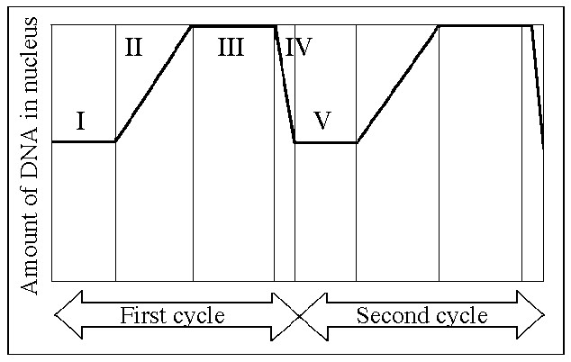

Figure 12.3

____ 20. In the figure above, mitosis is represented by which number?
a. | I
b. | II
c. | III
d. | IV
e. | V

____ 21. Which number represents the point in the cell cycle during which the chromosomes are replicated?
a. | I
b. | II
c. | III
d. | IV
e. | V

____ 22. MPF reaches its threshold concentration at the end of this stage.
a. | I
b. | II
c. | III
d. | IV
e. | V

____ 23. The MPF protein complex turns itself off by
a. | activating a process that destroys cyclin component.
b. | activating an enzyme that stimulates cyclin.
c. | binding to chromatin.
d. | exiting the cell.
e. | activating the anaphase-promoting complex.

____ 24. Which of the following describe(s) cyclin-dependent kinase (Cdk)?
a. | Cdk is inactive, or "turned off," in the presence of cyclin.
b. | Cdk is present throughout the cell cycle.
c. | Cdk is an enzyme that attaches phosphate groups to other proteins.
d. | Both A and B are true.
e. | Both B and C are true.

____ 25. The research team established similar lymphocyte cultures from a number of human donors, including healthy teenagers of both genders, patients already suffering from long-term bacterial infections, and elderly volunteers. They found that the increase in lymphocyte incorporation after pathogen introduction was slightly lower in some of the women teenagers and significantly lower in each of the elderly persons. They repeated the study with a larger number of samples but got the same results. What might be among their conclusions?
a. | The young women showed these results because they have poorer nutrition.
b. | The elderly persons' samples demonstrated their lowered immune responses.
c. | The young men had higher response because they are generally healthier.
d. | The patient samples should have had the lowest response but did not, so the experiment is invalid.
e. | The elderly donor samples represent cells no longer capable of any cell division.

____ 26. Cells from an advanced malignant tumor most often have very abnormal chromosomes, and often an abnormal total number of chromosomes. Why might this occur?
a. | Cancer cells are no longer density dependent.
b. | Cancer cells are no longer anchorage dependent.
c. | Chromosomally abnormal cells can still go through cell cycle checkpoints.
d. | Chromosomally abnormal cells still have normal metabolism.
e. | Transformation introduces new chromosomes into cells.

____ 27. One difference between cancer cells and normal cells is that cancer cells
a. | are unable to synthesize DNA.
b. | are arrested at the S phase of the cell cycle.
c. | continue to divide even when they are tightly packed together.
d. | cannot function properly because they are affected by density-dependent inhibition.
e. | are always in the M phase of the cell cycle.

____ 28. In the cells of some organisms, mitosis occurs without cytokinesis. This will result in
a. | cells with more than one nucleus.
b. | cells that are unusually small.
c. | cells lacking nuclei.
d. | destruction of chromosomes.
e. | cell cycles lacking an S phase.

____ 29. Which of the following does not occur during mitosis?
a. | condensation of the chromosomes
b. | replication of the DNA
c. | separation of sister chromatids
d. | spindle formation
e. | separation of the spindle poles

____ 30. Which of the following statements about genes is incorrect?
a. | Genes correspond to segments of DNA.
b. | Many genes contain the information needed for cells to synthesize enzymes and other proteins.
c. | During fertilization, both the sperm and the ovum contribute genes to the resulting fertilized egg.
d. | One gene only is used in a specific cell type.
e. | Genetic differences can result from changes in the DNA called mutations.

____ 31. The human X and Y chromosomes
a. | are both present in every somatic cell of males and females alike.
b. | are of approximately equal size and number of genes.
c. | are almost entirely homologous, despite their different names.
d. | include genes that determine an individual's sex.
e. | include only genes that govern sex determination.

____ 32. Which of the following is true of a species that has a chromosome number of 2n = 16?
a. | The species is diploid with 32 chromosomes per cell.
b. | The species has 16 sets of chromosomes per cell.
c. | Each cell has 8 homologous pairs.
d. | During the S phase of the cell cycle there will be 32 separate chromosomes.
e. | A gamete from this species has 4 chromosomes.

____ 33. Which of the following is an example of alternation of generations?
a. | A grandparent and grandchild each has dark hair, but the parent has blond hair.
b. | A diploid plant (sporophyte) produces, by meiosis, a spore that gives rise to a multicellular, haploid pollen grain (gametophyte).
c. | A diploid animal produces gametes by meiosis, and the gametes undergo fertilization to produce a diploid zygote.
d. | A haploid mushroom produces gametes by mitosis, and the gametes undergo fertilization, which is immediately followed by meiosis.
e. | A diploid cell divides by mitosis to produce two diploid daughter cells, which then fuse to produce a tetraploid cell.

Refer to the life cycles illustrated in Figure 13.1 to answer the following questions.

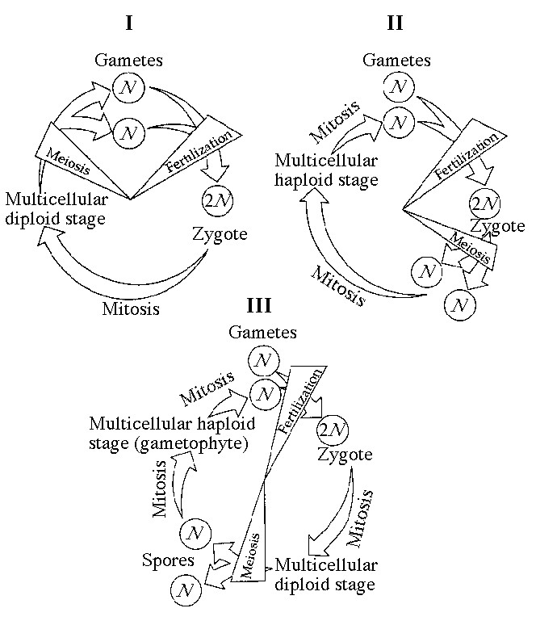

Figure 13.1

____ 34. Which of the life cycles is typical for animals?
a. | I only
b. | II only
c. | III only
d. | I and II
e. | I and III

____ 35. Which of the life cycles is typical for most fungi and some protists?
a. | I only
b. | II only
c. | III only
d. | I and II
e. | I and III

____ 36. The karyotype of one species of primate has 48 chromosomes. In a particular female, cell division goes awry and she produces one of her eggs with an extra chromosome (25). The most probable source of this error would be a mistake in which of the following?
a. | Mitosis in her ovary
b. | Metaphase I of one meiotic event
c. | Telophase II of one meiotic event
d. | Telophase I of one meiotic event
e. | Either anaphase I or II

____ 37. A given organism has 46 chromosomes in its karyotype. We can therefore conclude which of the following?
a. | It must be human.
b. | It must be a primate.
c. | It must be an animal.
d. | It must be sexually reproducing.
e. | Its gametes must have 23 chromosomes.

____ 38. A triploid cell contains three sets of chromosomes. If a cell of a usually diploid species with 42 chromosomes per cell is triploid, this cell would be expected to have which of the following?
a. | 63 chromosomes in 31 1/2 pairs
b. | 63 chromosomes in 21 sets of 3
c. | 63 chromosomes, each with three chromatids
d. | 21 chromosome pairs and 21 unique chromosomes

____ 39. A karyotype results from which of the following?
a. | A natural cellular arrangement of chromosomes in the nucleus
b. | An inherited ability of chromosomes to arrange themselves
c. | The ordering of human chromosome images
d. | The cutting and pasting of parts of chromosomes to form the standard array
e. | The separation of homologous chromosomes at metaphase I of meiosis

____ 40. After telophase I of meiosis, the chromosomal makeup of each daughter cell is
a. | diploid, and the chromosomes are each composed of a single chromatid.
b. | diploid, and the chromosomes are each composed of two chromatids.
c. | haploid, and the chromosomes are each composed of a single chromatid.
d. | haploid, and the chromosomes are each composed of two chromatids.
e. | tetraploid, and the chromosomes are each composed of two chromatids.

For the following questions, match the key event of meiosis with the stages listed below.

I. Prophase | IV. Prophase II
II. Metaphase I | VI. Metaphase II
III. Anaphase I | VII. Anaphase II
IV. Telophase I | VIII. Telophase II

____ 41. Which of the following happens at the conclusion of meiosis I?
a. | Homologous chromosomes are separated.
b. | The chromosome number per cell is conserved.
c. | Sister chromatids are separated.
d. | Four daughter cells are formed.
e. | The sperm cells elongate to form a head and a tail end.

Refer to the drawings in Figure 13.2 of a single pair of homologous chromosomes as they might appear during various stages of either mitosis or meiosis, and answer the following questions.

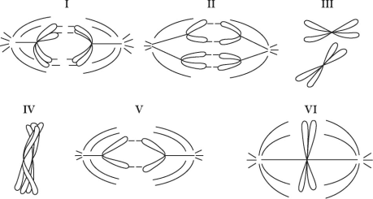

Figure 13.2

____ 42. Which diagram represents prophase I of meiosis?
a. | I
b. | II
c. | IV
d. | V
e. | VI

____ 43. Chromatids are separated from each other.
a. | The statement is true for mitosis only.
b. | The statement is true for meiosis I only.
c. | The statement is true for meiosis II only.
d. | The statement is true for mitosis and meiosis I.
e. | The statement is true for mitosis and meiosis II.

____ 44. You have in your possession a microscope slide with meiotic cells on it and a light microscope. What would you look for if you wanted to identify metaphase I cells on the slide?
a. | A visible nuclear envelope
b. | Separated sister chromatids at each pole of the cell
c. | Tetrads lined up at the center of the cell
d. | A synaptonemal complex
e. | A cleavage furrow

____ 45. Experiments with cohesions have found that
a. | cohesions are protected from destruction throughout meiosis I and II.
b. | cohesions are cleaved from chromosomes at the centromere before anaphase I.
c. | cohesions are protected from cleavage at the centromere during meiosis I.
d. | a protein cleaves cohesions before metaphase I.
e. | a protein that cleaves cohesions would cause cellular death.

____ 46. Chiasmata are what we see under a microscope that let us know which of the following is occurring?
a. | Asexual reproduction
b. | Meiosis II
c. | Anaphase II
d. | Crossing over
e. | Separation of homologs

____ 47. Independent assortment of chromosomes is a result of
a. | the random and independent way in which each pair of homologous chromosomes lines up at the metaphase plate during meiosis I.
b. | the random nature of the fertilization of ova by sperm.
c. | the random distribution of the sister chromatids to the two daughter cells during anaphase II.
d. | the relatively small degree of homology shared by the X and Y chromosomes.
e. | All of the above

____ 48. A human cell containing 22 autosomes and a Y chromosome is
a. | a sperm.
b. | an egg.
c. | a zygote.
d. | a somatic cell of a male.
e. | a somatic cell of a female.

____ 49. Which life cycle stage is found in plants but not animals?
a. | Gamete
b. | Zygote
c. | Multicellular diploid
d. | Multicellular haploid
e. | Unicellular diploid

____ 50. Homologous chromosomes move toward opposite poles of a dividing cell during
a. | mitosis.
b. | meiosis I.
c. | meiosis II.
d. | fertilization.
e. | binary fission.

____ 51. How many different combinations of maternal and paternal chromosomes can be packaged in gametes made by an organism with a diploid number of 8 (2n = 8)?
a. | 2
b. | 4
c. | 8
d. | 16
e. | 32

____ 52. A cross between homozygous purple-flowered and homozygous white-flowered pea plants results in offspring with purple flowers. This demonstrates
a. | the blending model of genetics.
b. | true-breeding.
c. | dominance.
d. | a dihybrid cross.
e. | the mistakes made by Mendel.

____ 53. The offspring of Mendel's classic pea cross always looked like one of the two parental varieties because
a. | one phenotype was completely dominant over another.
b. | each allele affected phenotypic expression.
c. | the traits blended together during fertilization.
d. | no genes interacted to produce the parental phenotype.
e. | different genes interacted to produce the parental phenotype.

____ 54. What was the most significant conclusion that Gregor Mendel drew from his experiments with pea plants?
a. | There is considerable genetic variation in garden peas.
b. | Traits are inherited in discrete units, and are not the results of "blending."
c. | Recessive genes occur more frequently in the than do dominant ones.
d. | Genes are composed of DNA.
e. | An organism that is homozygous for many recessive traits is at a disadvantage.

____ 55. A sexually reproducing animal has two unlinked genes, one for head shape (H) and one for tail length (T). Its genotype is HhTt. Which of the following genotypes is possible in a gamete from this organism?
a. | HT
b. | Hh
c. | HhTt
d. | T
e. | tt

____ 56. It was important that Mendel examined not just the generation in his breeding experiments, but the generation as well, because
a. | he obtained very few progeny, making statistical analysis difficult.
b. | parental traits that were not observed in the reappeared in the .
c. | analysis of the progeny would have allowed him to discover the law of segregation, but not the law of independent assortment.
d. | the dominant phenotypes were visible in the generation, but not in the .
e. | many of the progeny died.

____ 57. When crossing an organism that is homozygous recessive for a single trait with a heterozygote, what is the chance of producing an offspring with the homozygous recessive phenotype?
a. | 0%
b. | 25%
c. | 50%
d. | 75%
e. | 100%

Use Figure 14.1 and the following description to answer the questions below.

In a particular plant, leaf color is controlled by gene locus D. Plants with at least one allele D have dark green leaves, and plants with the homozygous recessive dd genotype have light green leaves. A true-breeding dark-leaved plant is crossed with a light-leaved one, and the offspring is allowed to self-pollinate. The predicted outcome of the is diagrammed in the Punnett square shown in Figure 14.1, where 1, 2, 3, and 4 represent the genotypes corresponding to each box within the square.

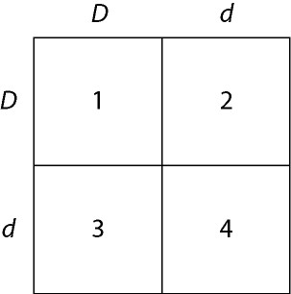

Figure 14.1

____ 58. Which of the boxes marked 1-4 correspond to plants with dark leaves?
a. | 1 only
b. | 1 and 2
c. | 2 and 3
d. | 4 only
e. | 1, 2, and 3

____ 59. Which of the boxes correspond to plants with a heterozygous genotype?
a. | 1
b. | 1 and 2
c. | 1, 2, and 3
d. | 2 and 3
e. | 2, 3, and 4

____ 60. Which of the plants will be true-breeding?
a. | 1 and 4
b. | 2 and 3
c. | 1—4
d. | 1 only
e. | None

____ 61. Mendel accounted for the observation that traits which had disappeared in the generation reappeared in the generation by proposing that
a. | new mutations were frequently generated in the progeny, "reinventing" traits that had been lost in the .
b. | the mechanism controlling the appearance of traits was different between the and the plants.
c. | traits can be dominant or recessive, and the recessive traits were obscured by the dominant ones in the .
d. | the traits were lost in the due to blending of the parental traits.
e. | members of the generation had only one allele for each character, but members of the had two alleles for each character.

____ 62. The fact that all seven of the pea plant traits studied by Mendel obeyed the principle of independent assortment most probably indicates which of the following?
a. | None of the traits obeyed the law of segregation.
b. | The diploid number of chromosomes in the pea plants was 7.
c. | All of the genes controlling the traits were located on the same chromosome.
d. | All of the genes controlling the traits behaved as if they were on different chromosomes.
e. | The formation of gametes in plants occurs by mitosis only.

____ 63. Mendel's observation of the segregation of alleles in gamete formation has its basis in which of the following phases of cell division?
a. | Prophase I of meiosis
b. | Prophase II of meiosis
c. | Metaphase I of meiosis
d. | Anaphase I of meiosis
e. | Anaphase of mitosis

____ 64. Mendel's second law of independent assortment has its basis in which of the following events of meiosis I?
a. | Synapsis of homologous chromosomes
b. | Crossing over
c. | Alignment of tetrads at the equator
d. | Separation of homologs at anaphase
e. | Separation of cells at telophase

____ 65. In certain plants, tall is dominant to short. If a heterozygous plant is crossed with a homozygous tall plant, what is the probability that the offspring will be short?
a. | 1
b. | 1/2
c. | 1/4
d. | 1/6
e. | 0

____ 66. Two true-breeding stocks of pea plants are crossed. One parent has red, axial flowers and the other has white, terminal flowers; all individuals have red, axial flowers. The genes for flower color and location assort independently. If 1,000 offspring resulted from the cross, approximately how many of them would you expect to have red, terminal flowers?
a. | 65
b. | 190
c. | 250
d. | 565
e. | 750

____ 67. Given the parents AABBCc × AabbCc, assume simple dominance and independent assortment. What proportion of the progeny will be expected to phenotypically resemble the first parent?
a. | 1/4
b. | 1/8
c. | 3/4
d. | 3/8
e. | 1

Use the following information to answer the questions below.

Radish flowers may be red, purple, or white. A cross between a red-flowered plant and a white-flowered plant yields all-purple offspring. The part of the radish we eat may be oval or long, with long being the dominant characteristic.

____ 68. If true-breeding red long radishes are crossed with true breeding white oval radishes, the will be expected to be which of the following?
a. | Red and long
b. | Red and oval
c. | White and long
d. | Purple and long
e. | Purple and oval

____ 69. In the generation of the above cross, which of the following phenotypic ratios would be expected?
a. | 9:3:3:1
b. | 9:4:3
c. | 1:1:1:1
d. | 1:1:1:1:1:1
e. | 6:3:3:2:1:1

____ 70. Tallness (T) in snapdragons is dominant to dwarfness (t), while red (R) flower color is dominant to white (r). The heterozygous condition results in pink (Rr) flower color. A dwarf, red snapdragon is crossed with a plant homozygous for tallness and white flowers. What are the genotype and phenotype of the individuals?
a. | ttRr–dwarf and pink
b. | ttrr–dwarf and white
c. | TtRr–tall and red
d. | TtRr–tall and pink
e. | TTRR–tall and red

____ 71. In cattle, roan coat color (mixed red and white hairs) occurs in the heterozygous (Rr) offspring of red (RR) and white (rr) homozygotes. Which of the following crosses would produce offspring in the ratio of 1 red : 2 roan : 1 white?
a. | red × white
b. | roan × roan
c. | white × roan
d. | red × roan
e. | The answer cannot be determined from the information provided.

Refer to the following to answer the questions below.

Gene S controls the sharpness of spines in a type of cactus. Cactuses with the dominant allele, S, have sharp spines, whereas homozygous recessive ss cactuses have dull spines. At the same time, a second gene, N, determines whether cactuses have spines. Homozygous recessive nn cactuses have no spines at all.

____ 72. A cross between a true-breeding sharp-spined cactus and a spineless cactus would produce
a. | all sharp-spined progeny.
b. | 50% sharp-spined, 50% dull-spined progeny.
c. | 25% sharp-spined, 50% dull-spined, 25% spineless progeny
d. | all spineless progeny.
e. | It is impossible to determine the phenotypes of the progeny.

Use the following information to answer the questions below.

A woman who has blood type A positive has a daughter who is type O positive and a son who is type B negative. Rh positive is a trait that shows simple dominance over Rh negative and is designated by the alleles R and r, respectively. A third gene for the MN blood group has codominant alleles M and N.

____ 73. Which of the following is a possible partial genotype for the son?
a.
b.
c. | ii
d.
e.

____ 74. Hydrangea plants of the same genotype are planted in a large flower garden. Some of the plants produce blue flowers and others pink flowers. This can be best explained by which of the following?
a. | Environmental factors such as soil pH
b. | The allele for blue hydrangea being completely dominant
c. | The alleles being codominant
d. | The fact that a mutation has occurred
e. | Acknowledging that multiple alleles are involved

____ 75. Which of the following provides an example of epistasis?
a. | Recessive genotypes for each of two genes (aabb) results in an albino corn snake.
b. | The allele b17 produces a dominant phenotype, although b1 through b16 do not.
c. | In rabbits and many other mammals, one genotype (cc) prevents any fur color from developing.
d. | In Drosophila (fruit flies), white eyes can be due to an X-linked gene or to a combination of other genes.

____ 76. Most genes have many more than two alleles. However, which of the following is also true?
a. | At least one allele for a gene always produces a dominant phenotype.
b. | Most of the alleles will never be found in a live-born organism.
c. | All of the alleles but one will produce harmful effects if homozygous.
d. | There may still be only two phenotypes for the trait.
e. | More than two alleles in a genotype is lethal.

The following questions refer to the pedigree chart in Figure 14.2 for a family, some of whose members exhibit the dominant trait, wooly hair. Affected individuals are indicated by an open square or circle.

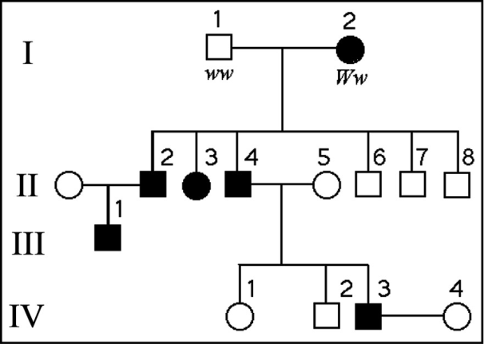

Figure 14.2

____ 77. What is the genotype of individual II-5?
a. | WW
b. | Ww
c. | ww
d. | WW or ww
e. | ww or Ww

____ 78. What is the probability that individual III-1 is Ww?
a. | 3/4
b. | 1/4
c. | 2/4
d. | 2/3
e. | 1

____ 79. People with sickle-cell trait
a. | are heterozygous for the sickle-cell allele.
b. | are usually healthy.
c. | have increased resistance to malaria.
d. | produce normal and abnormal hemoglobin.
e. | All of the above

____ 80. An obstetrician knows that one of her patients is a pregnant woman whose fetus is at risk for a serious disorder that is detectable biochemically in fetal cells. The obstetrician would most reasonably offer which of the following procedures to her patient?
a. | CVS
b. | Ultrasound imaging
c. | Amniocentesis
d. | Fetoscopy
e. | X-ray

____ 81. Phenylketonuria (PKU) is a recessive human disorder in which an individual cannot appropriately metabolize a particular amino acid. This amino acid is not otherwise produced by humans. Therefore the most efficient and effective treatment is which of the following?
a. | Feed them the substrate that can be metabolized into this amino acid.
b. | Transfuse the patients with blood from unaffected donors.
c. | Regulate the diet of the affected persons to severely limit the uptake of the amino acid.
d. | Feed the patients the missing enzymes in a regular cycle, i.e., twice per week.

____ 82. Sturtevant provided genetic evidence for the existence of four pairs of chromosomes in Drosophila in which of these ways?
a. | There are four major functional classes of genes in Drosophila.
b. | Drosophila genes cluster into four distinct groups of linked genes.
c. | The overall number of genes in Drosophila is a multiple of four.
d. | The entire Drosophila genome has approximately 400 map units.
e. | Drosophila genes have, on average, four different alleles.

____ 83. A man with Klinefelter syndrome (47, XXY) is expected to have any of the following EXCEPT
a. | lower sperm count.
b. | possible breast enlargement.
c. | increased testosterone.
d. | long limbs.
e. | female body characteristics.

____ 84. A woman is found to have 47 chromosomes, including 3 X chromosomes. Which of the following describes her expected phenotype?
a. | Masculine characteristics such as facial hair
b. | Enlarged genital structures
c. | Excessive emotional instability
d. | Normal female
e. | Sterile female

____ 85. Red-green color blindness is a sex-linked recessive trait in humans. Two people with normal color vision have a color-blind son. What are the genotypes of the parents?
a. | and
b. | and
c. | and
d. | and
e. | and

____ 86. In birds, sex is determined by a ZW chromosome scheme. Males are ZZ and females are ZW. A recessive lethal allele that causes death of the embryo is sometimes present on the Z chromosome in pigeons. What would be the sex ratio in the offspring of a cross between a male that is heterozygous for the lethal allele and a normal female?
a. | 2:1 male to female
b. | 1:2 male to female
c. | 1:1 male to female
d. | 4:3 male to female
e. | 3:1 male to female

Refer to the following information to answer the questions below.

A man who is an achondroplastic dwarf with normal vision marries a color-blind woman of normal height. The man's father was six feet tall, and both the woman's parents were of average height. Achondroplastic dwarfism is autosomal dominant, and red-green color blindness is X-linked recessive.

____ 87. How many of their daughters might be expected to be color-blind dwarfs?
a. | All
b. | None
c. | Half
d. | One out of four
e. | Three out of four

____ 88. A 0.1% frequency of recombination is observed
a. | only in sex chromosomes.
b. | only on genetic maps of viral chromosomes.
c. | on unlinked chromosomes.
d. | in any two genes on different chromosomes.
e. | in genes located very close to one another on the same chromosome.

____ 89. What is the mechanism for the production of genetic recombinants?
a. | X inactivation
b. | Methylation of cytosine
c. | Crossing over and independent assortment
d. | Nondisjunction
e. | Deletions and duplications during meiosis

Refer to Figure 15.2 to answer the following questions.

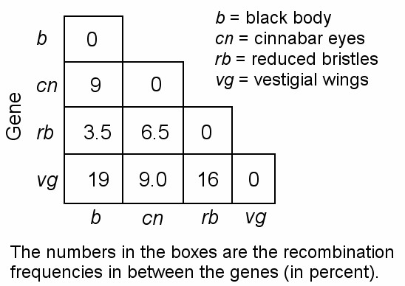

Figure 15.2

____ 90. Which of the following two genes are closest on a genetic map of Drosophila?
a. | b and vg
b. | vg and cn
c. | rb and cn
d. | cn and b
e. | b and rb

D, F, and J are three genes in Drosophila. The recombination frequencies for two of the three genes are shown in Figure 15.3.

Figure 15.3

____ 91. The frequency of crossing over between any two linked genes will be which of the following?
a. | Higher if they are recessive
b. | Dependent on how many alleles there are
c. | Determined by their relative dominance
d. | The same as if they were not linked
e. | Proportional to the distance between them

____ 92. A cell that has 2n + 1 chromosomes is
a. | trisomic.
b. | monosomic.
c. | euploid.
d. | polyploid.
e. | triploid.

____ 93. One possible result of chromosomal breakage is for a fragment to join a nonhomologous chromosome. What is this alteration called?
a. | Deletion
b. | Disjunction
c. | Inversion
d. | Translocation
e. | Duplication

____ 94. In humans, male-pattern baldness is controlled by an autosomal gene that occurs in two allelic forms. Allele Hn determines nonbaldness, and allele Hb determines pattern baldness. In males, because of the presence of testosterone, allele Hb is dominant over Hn. If a man and woman both with genotype HnHb have a son, what is the chance that he will eventually be bald?
a. | 0%
b. | 25%
c. | 33%
d. | 50%
e. | 75%

____ 95. An inversion in a human chromosome often results in no demonstrable phenotypic effect in the individual. What else may occur?
a. | There may be deletions later in life.
b. | Some abnormal gametes may be formed.
c. | There is an increased frequency of mutation.
d. | All inverted chromosomes are deleted.
e. | The individual is more likely to get cancer.

____ 96. What is the source of the extra chromosome 21 in an individual with Down syndrome?
a. | Nondisjunction in the mother only
b. | Nondisjunction in the father only
c. | Duplication of the chromosome
d. | Nondisjunction or translocation in either parent
e. | It is impossible to detect with current technology

____ 97. A couple has a child with Down syndrome when the mother is 39 years old at the time of delivery. Which is the most probable cause?
a. | The woman inherited this tendency from her parents.
b. | One member of the couple carried a translocation.
c. | One member of the couple underwent nondisjunction in somatic cell production.
d. | One member of the couple underwent nondisjunction in gamete production.

____ 98. In 1956 Tijo and Levan first successfully counted human chromosomes. The reason it would have taken so many years to have done so would have included all but which of the following?
a. | Watson and Crick's structure of DNA was not done until 1953.
b. | Chromosomes were piled up on top of one another in the nucleus.
c. | Chromosomes were not distinguishable during interphase.
d. | A method had not yet been devised to halt mitosis at metaphase.

____ 99. A gene is considered to be non-Mendelian in its inheritance pattern if it seems to "violate" Mendel's laws. Which of the following would then NOT be considered non-Mendelian?
a. | A gene whose expression varies depending on the gender of the transmitting parent
b. | A gene derived solely from maternal inheritance
c. | A gene transmitted via the cytoplasm or cytoplasmic structures
d. | A gene transmitted to males from the maternal line and from fathers to daughters
e. | A gene transmitted by a virus to egg-producing cells

____ 100. Mitochondrial DNA is primarily involved in coding for proteins needed for electron transport. Therefore in which body systems would you expect most mitochondrial gene mutations to be exhibited?
a. | The immune system and the blood
b. | Excretory and respiratory systems
c. | The skin and senses
d. | Nervous and muscular systems
e. | Circulation

Short Answer

Use the diagram of a cell in Figure 13.5 to answer the following questions.

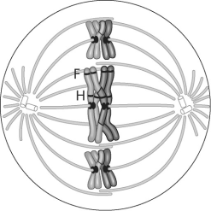

Figure 13.5

101. How can you tell this cell is undergoing meiosis, not mitosis?

102. In some plants, a true-breeding, red-flowered strain gives all pink flowers when crossed with a white-flowered strain: (red) × (white) → (pink). If flower position (axial or terminal) is inherited as it is in peas (see Table 14.1 in your textbook), what will be the ratios of genotypes and phenotypes of the generation resulting from the following cross: axial-red (true-breeding) × terminal-white? What will be the ratios in the generation?

103. What is the probability that each of the following pairs of parents will produce the indicated offspring? (Assume independent assortment of all gene pairs.)
A) AABBCC × aabbcc → AaBbCc
B) AABbCc × AaBbCc → AAbbCC
C) AaBbCc × AaBbCc → AaBbCc
D) aaBbCC × AABbcc → AaBbCc

104. In tigers, a recessive allele causes an absence of fur pigmentation (a white tiger) and a cross-eyed condition. If two phenotypically normal tigers that are heterozygous at this locus are mated, what percentage of their offspring will be cross-eyed? What percentage will be white?

105. In mice, black color (B) is dominant to white (b). At a different locus, a dominant allele (A) produces a band of yellow just below the tip of each hair in mice with black fur. This gives a frosted appearance known as agouti. Expression of the recessive allele (a) results in a solid coat color. If mice that are heterozygous at both loci are crossed, what is the expected phenotypic ratio of their offspring?

106. A man with hemophilia (a recessive, sex-linked condition) has a daughter of normal phenotype. She marries a man who is normal for the trait. What is the probability that a daughter of this mating will be a hemophiliac? That a son will be a hemophiliac? If the couple has four sons, what is the probability that all four will be born with hemophilia?

107. Red-green color blindness is caused by a sex-linked recessive allele. A color-blind man marries a woman with normal vision whose father was color-blind. What is the probability that they will have a color-blind daughter? What is the probability that their first son will be color-blind? (Note the different wording in the two questions.)

108. What pattern of inheritance would lead a geneticist to suspect that an inherited disorder of cell metabolism is due to a defective mitochondrial gene?

109. Women born with an extra X chromosome (XXX) are healthy and phenotypically indistinguishable from normal XX women. What is a likely explanation for this finding? How could you test this explanation?

110. You design Drosophila crosses to provide recombination data for gene a, which is located on the chromosome shown in Figure 15.12 in the textbook. Gene a has recombination frequencies of 14% with the vestigial-wing locus and 26% with the brown-eye locus. Where is a located on the chromosome?

Matching

Match each term with the correct statement below.
a. | Gene
b. | Allele
c. | Character
d. | Trait
e. | Dominant allele
f. | Recessive allele
g. | Genotype
h. | Phenotype
i. | Homozygous
j. | Heterozygous
k. | Testcross
l. | Monohybrid cross

____ 111. An organism’s appearance or observable traits

____ 112. A cross between an individual with an unknown genotype and homozygous recessive individual

____ 113. Having two identical alleles for a gene

____ 114. The genetic makeup of an individual

____ 115. An alternative version of a gene

____ 116. Has no effect on phenotype in a heterozygote

____ 117. Having two different alleles for a gene

____ 118. A heritable unit that determines a character and can exist in different forms.

____ 119. A cross between individuals heterozygous for a single character

____ 120. A heritable feature that varies among individuals

