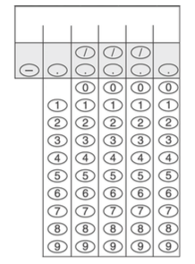
AP Biology Grid in Questions
- In a particular species of guppy, tails can either be long or short and either feathered or straight. A mating between a short feather-tailed female and a short straight-tailed male produces 30 short straight-tailed guppies, 42 short feather-tailed guppies, 10 long straight- tailed guppies, and 14 long feather-tailed guppies. Calculate the chi-squared value for the null hypothesis that the short feather-tailed guppy was heterozygous for the feather-tailed gene. Give your answer to the nearest hundredth.

- What is the probability that the genotype rrss will be produced by a cross in which the genotypes of the parents are both RrSs?

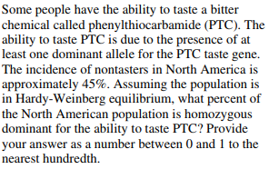
3.

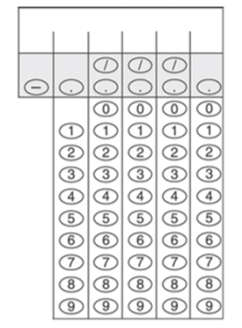
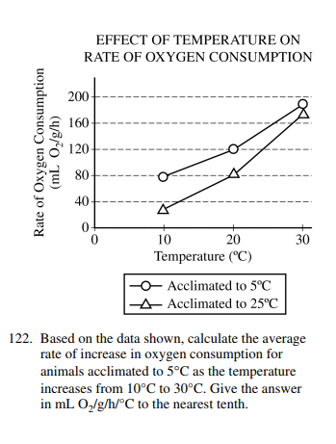
4.

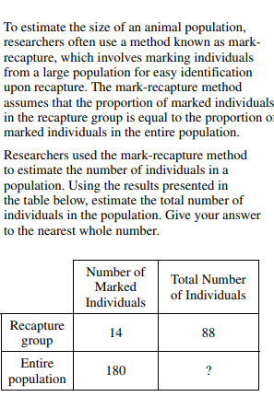
5.

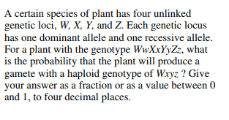
6.

7.
