Name:
Mitosis
A single fertilized human egg cell will divide to form two cells. These two cells will each divide into two cells. In time, millions of cells are produced. The division of nuclear material in which each new nucleus obtains the same number of chromosomes and the same nuclear code as the original nucleus is called mitosis. Mitosis occurs in four phases. There is an interphase after each mitosis.
In this investigation you will
- Locate cells in prepared onion root slides that are in the process of dividing by mitosis.
- Identify cells in interphase and in each of the four stages of mitosis in the onion root tips by comparing them to diagrams.
- Study the changes which occur in a cell as it undergoes mitosis.
Materials:  Microscope  Prepared slides of onion root tip(Allium), longitudinal section  Procedure  * Locate with a microscope the region of rapidly dividing cells on the prepared slide of onion roottip as shown in figure 15-1. After lacating the cellsunder low power, awitch to high power.  * Locate cells that appear to be in the various stages of mitosis. Use Figure 15-2 as a guide  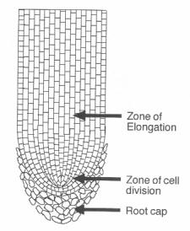. | *identify and label the following stages by using the brief description provided. Write the correct satge on the lines provided in figure 15-2.  - Interphase: cell contains easily seen nucleus and nucleolus – chromosomes appear as finedots within nucleus.  - Prophase: cell nucleus enlarged – nucleolus no longer visible – chromosomes appear as short strands within nucleus.  - Metaphase: chromosomes long and thinatransds – chromosomes lined up along cellcenter and look like “spider on a mirror”.  - Anaphase: two sets of separate chromosomes can be seen – look as if they are being pulledapart from one another.  - Telophase: chromosomes appear at opposite ends of the cell- middle of the cell has line acrosscenter that divides it almost into two cells.  - Daughter cells: appear as cells in interphase but smaller and side by side – actually start interphase
1--------------------------------  2--------------------------------  3--------------------------------  4--------------------------------  5--------------------------------  6--------------------------------  7-------------------------------  8------------------------------- | 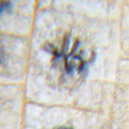  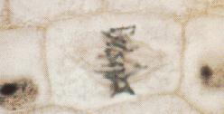  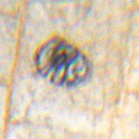  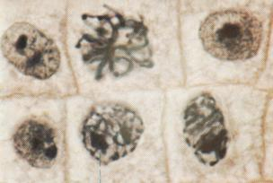  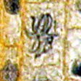  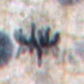  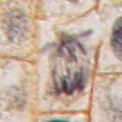  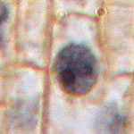  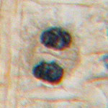 | 9---------------------------  10--------------------------  11--------------------------  12--------------------------  13--------------------------  14--------------------------  15--------------------------  16--------------------------  Figure 15-2

Answer the following questions about each of the phases of mitosis | 7) What other important events occur during  interphase?----------------------------------------------  Figure 15-4 Prophase  chromosomes  Prophase  *Locate cells resembling Figure 15-4. Answer  questions 8 & 9 while observing these cells.  8) Are chromosomes now visible during  prophase?-------------------------------------  ----------------------------------------------------  9)Describe the changes that have occurred to the  nucleolus and nuclear membrane from interphase  to prophase.--------------------------------------------------  - ----------------------------------------------------------------  *Use your text for reference while answering  question 10.  10)Explain why chromosomes can now be observed  but were not observable during interphase.--------  -----------------------------------------------------------------
Figure 15-3
Interphase

Nucleus
nucleolus

Interphase
* Locate cells resembling Figure 15-3. Answer questions 1-3 while observing these cells.
1) Describe the contents of a nucleus during interphase.----------------------------------------------
2) Are a nucleolus and a nuclear membrane present in the cell? ------------------------------------
3) Are distinct rod-shape structures called chromosomes easily observed in the nucleus at this time?------------------------------------------------
* Use your text for reference while answering questions 4-6.
4) Are chromosomes present in cells during interphase?---------------------------------------------
5) What terms used to describe nuclear contents during interphase?------------------------------------
6) What important event occur to chromosomes during interphase?-------------------------------------

Figure 15-5 Metaphase  Locate cells resembling Figure 15-5. Answer questions 11 & 12 while observing these cells.  11) Describe where the chromosomes are now located in relation to the cell.----------------------------  ------------------------------------------------------------------  12) Can evidence of chromosome duplication (replication) now be observed? ---------------------------------------------------  Figure 15-6 Anaphase-  *Locate cells resembling Figure 15-6. Answer questions 13 & 14 while  observing these cells  13) In metaphase, chromosome pairs were lined up along the cell’s center. Describe what is occurring to each chromosome pair during anaphase.---------------------------------------------  ------------------------------------------------------------  --------------------------------------------------------- | 14) toward what area of the cell are the chromosomes being directed?------------------------  ----------------------------------------  Figure 15-7 Telophase  *Locate cells resembling Figure 15-7. Answer question 15 & 16 while observing theses cells.  15) what cell parts begin to reappear during this phase?------------------------------------------------  16)Describe the location of the chromosomes now compared to where they were during metaphase.  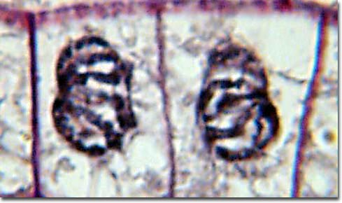  ------------------------------------------------------------  Figure 15-8 Daughter cells  16) How many cells have now formed from an original cell?-----------------------  17)Compare the number of chromosomes in daughter cells to that in the original cell.------------------------------------------------------------------

